**BASE MODEL**  
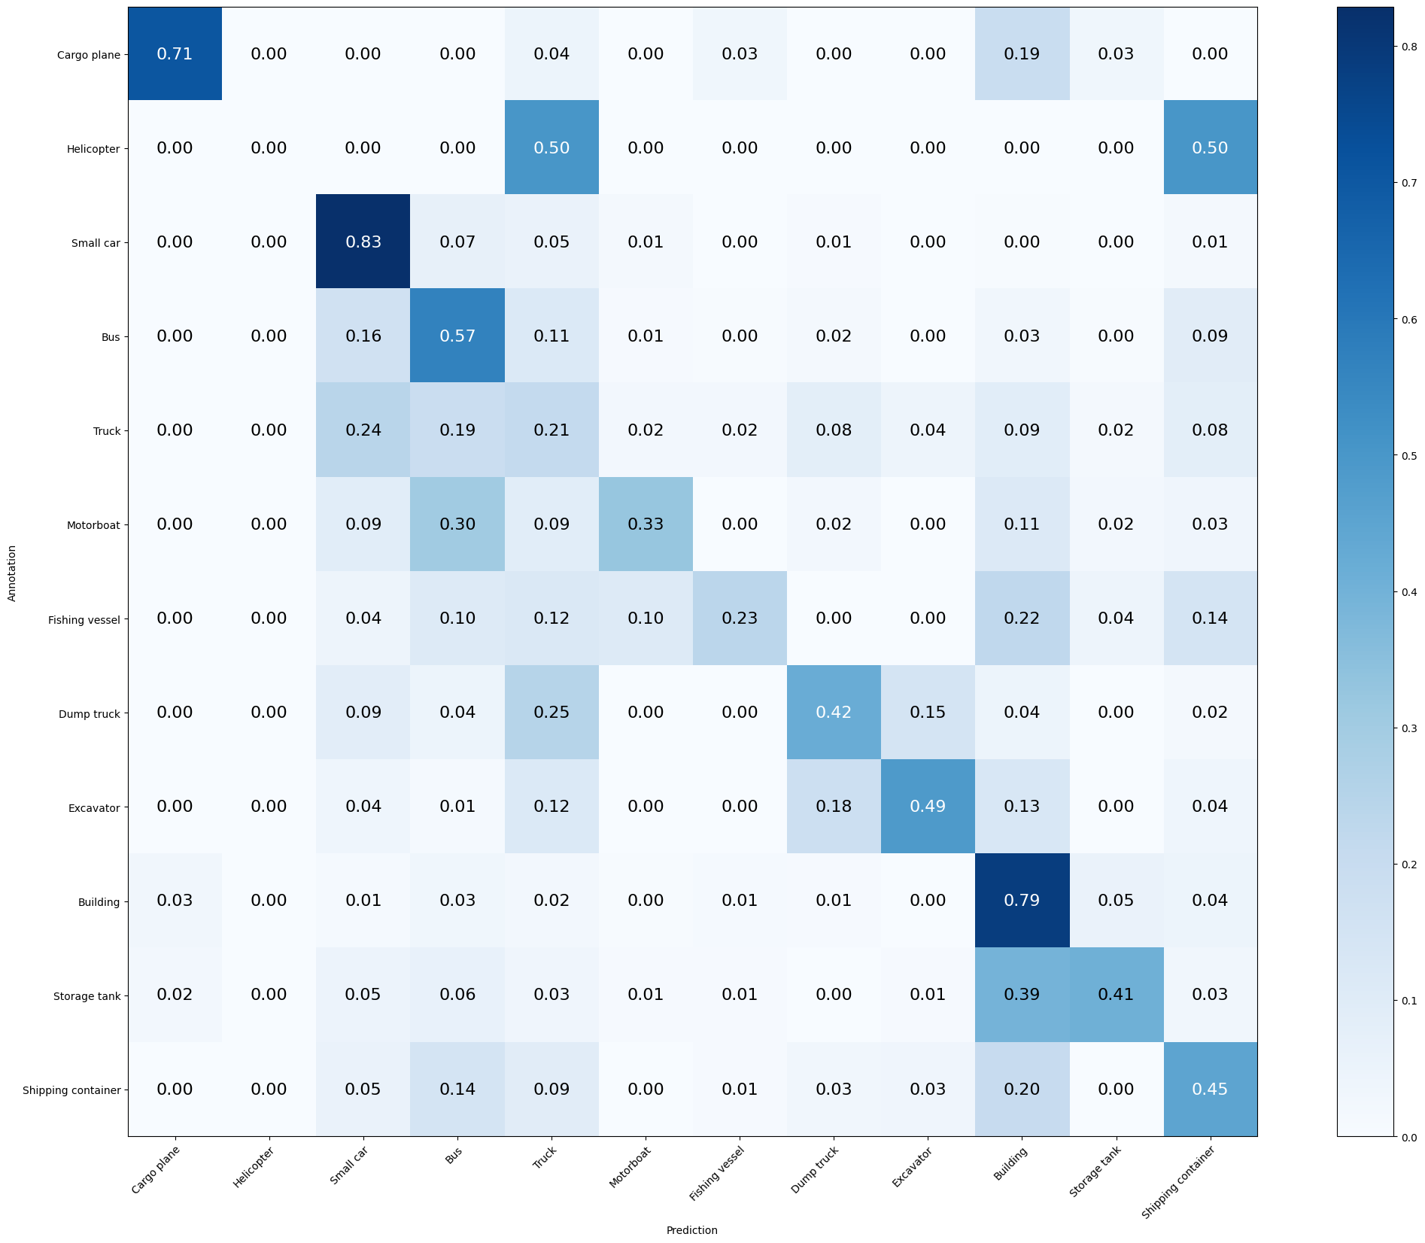

Mean Accuracy: 57.577%

Mean Recall: 45.143%

Mean Precision: 49.329%

> Cargo plane: Recall: 70.588% Precision: 73.846% Specificity: 99.179% Dice: 72.180%

> Helicopter: Recall: 0.000% Precision: 0.000% Specificity: 100.000% Dice: 0.000%

> Small car: Recall: 82.857% Precision: 70.588% Specificity: 91.560% Dice: 76.232%

> Bus: Recall: 56.621% Precision: 42.759% Specificity: 91.350% Dice: 48.723%

> Truck: Recall: 21.132% Precision: 29.016% Specificity: 92.686% Dice: 24.454%

> Motorboat: Recall: 32.584% Precision: 53.704% Specificity: 98.780% Dice: 40.559%

> Fishing vessel: Recall: 23.377% Precision: 50.000% Specificity: 99.127% Dice: 31.858%

> Dump truck: Recall: 41.880% Precision: 48.039% Specificity: 97.378% Dice: 44.749%

> Excavator: Recall: 48.718% Precision: 51.351% Specificity: 98.252% Dice: 50.000%

> Building: Recall: 78.629% Precision: 68.662% Specificity: 89.160% Dice: 73.308%

> Storage tank: Recall: 40.523% Precision: 61.386% Specificity: 98.035% Dice: 48.819%

> Shipping container: Recall: 44.805% Precision: 42.593% Specificity: 95.312% Dice: 43.671%

**MODEL 1**: Normalize after activation function

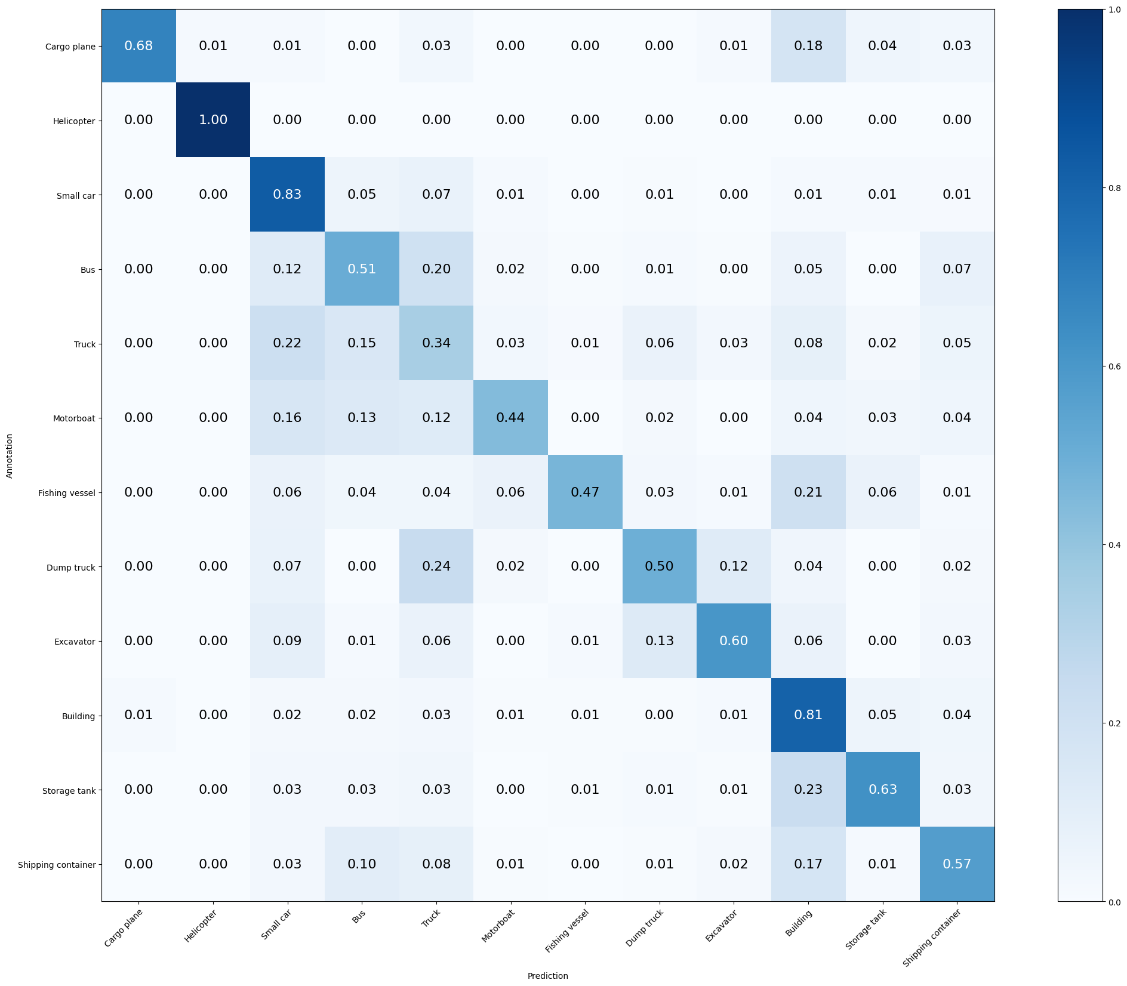

Mean Accuracy: 63.704%

Mean Recall: 61.372%

Mean Precision: 62.228%

> Cargo plane: Recall: 67.647% Precision: 86.792% Specificity: 99.662% Dice: 76.033%

> Helicopter: Recall: 100.000% Precision: 50.000% Specificity: 99.906% Dice: 66.667%

> Small car: Recall: 82.857% Precision: 72.050% Specificity: 92.142% Dice: 77.076%

> Bus: Recall: 50.685% Precision: 51.389% Specificity: 94.528% Dice: 51.034%

> Truck: Recall: 34.340% Precision: 37.449% Specificity: 91.885% Dice: 35.827%

> Motorboat: Recall: 43.820% Precision: 57.353% Specificity: 98.585% Dice: 49.682%

> Fishing vessel: Recall: 46.753% Precision: 80.000% Specificity: 99.563% Dice: 59.016%

> Dump truck: Recall: 49.573% Precision: 58.000% Specificity: 97.922% Dice: 53.456%

> Excavator: Recall: 60.256% Precision: 57.317% Specificity: 98.301% Dice: 58.750%

> Building: Recall: 80.645% Precision: 73.665% Specificity: 91.291% Dice: 76.997%

> Storage tank: Recall: 62.745% Precision: 66.667% Specificity: 97.582% Dice: 64.646%

> Shipping container: Recall: 57.143% Precision: 56.051% Specificity: 96.522% Dice: 56.592%

**MODEL 2**: Normalize before activation function

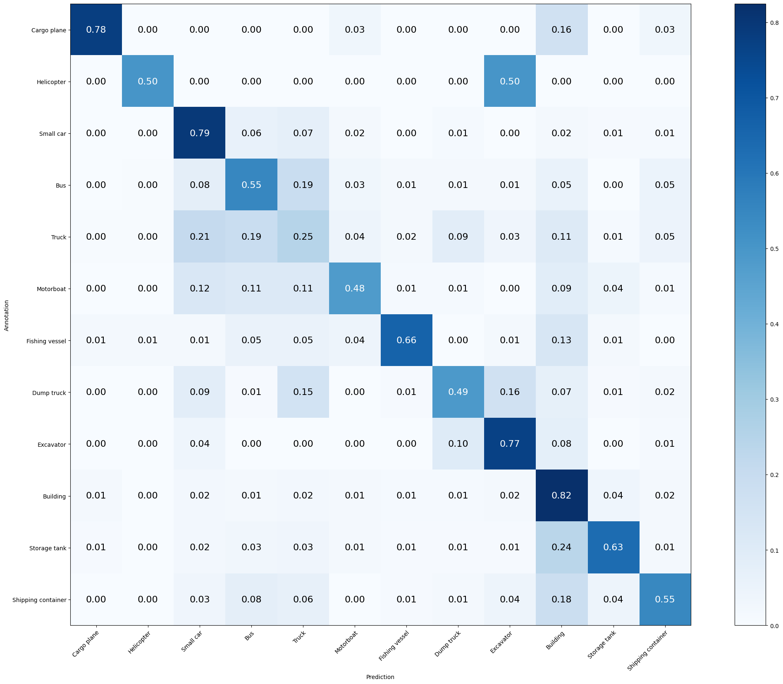

Mean Accuracy: 64.219%

Mean Recall: 60.595%

Mean Precision: 59.082%

> Cargo plane: Recall: 77.941% Precision: 84.127% Specificity: 99.517% Dice: 80.916%

> Helicopter: Recall: 50.000% Precision: 20.000% Specificity: 99.813% Dice: 28.571%

> Small car: Recall: 79.286% Precision: 74.330% Specificity: 93.306% Dice: 76.728%

> Bus: Recall: 54.795% Precision: 51.064% Specificity: 94.007% Dice: 52.863%

> Truck: Recall: 24.528% Precision: 33.333% Specificity: 93.059% Dice: 28.261%

> Motorboat: Recall: 48.315% Precision: 51.807% Specificity: 98.048% Dice: 50.000%

> Fishing vessel: Recall: 66.234% Precision: 75.000% Specificity: 99.175% Dice: 70.345%

> Dump truck: Recall: 48.718% Precision: 54.286% Specificity: 97.625% Dice: 51.351%

> Excavator: Recall: 76.923% Precision: 55.046% Specificity: 97.621% Dice: 64.171%

> Building: Recall: 82.460% Precision: 72.518% Specificity: 90.560% Dice: 77.170%

> Storage tank: Recall: 63.399% Precision: 71.852% Specificity: 98.086% Dice: 67.361%

> Shipping container: Recall: 54.545% Precision: 65.625% Specificity: 97.782% Dice: 59.574%

**MODEL 3**: Lasso Regularization (L1)

1)

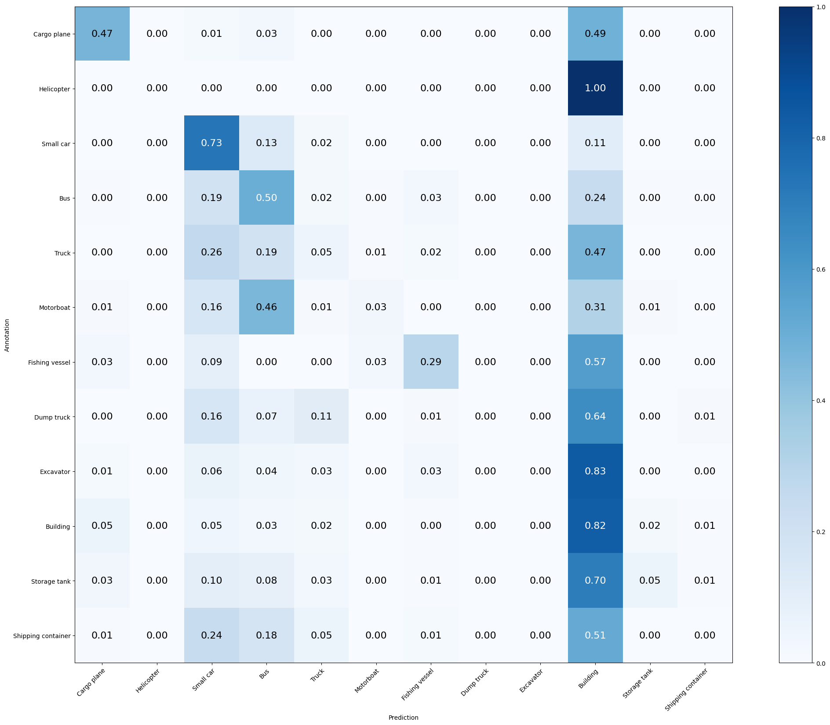

Mean Accuracy: 42.236%

Mean Recall: 24.560%

Mean Precision: 26.501%

> Cargo plane: Recall: 47.059% Precision: 46.377% Specificity: 98.213% Dice: 46.715%

> Helicopter: Recall: 0.000% Precision: 0.000% Specificity: 100.000% Dice: 0.000%

> Small car: Recall: 73.095% Precision: 56.957% Specificity: 86.496% Dice: 64.025%

> Bus: Recall: 50.228% Precision: 33.846% Specificity: 88.796% Dice: 40.441%

> Truck: Recall: 4.906% Precision: 20.635% Specificity: 97.330% Dice: 7.927%

> Motorboat: Recall: 3.371% Precision: 33.333% Specificity: 99.707% Dice: 6.122%

> Fishing vessel: Recall: 28.571% Precision: 53.659% Specificity: 99.078% Dice: 37.288%

> Dump truck: Recall: 0.000% Precision: 0.000% Specificity: 100.000% Dice: 0.000%

> Excavator: Recall: 0.000% Precision: 0.000% Specificity: 100.000% Dice: 0.000%

> Building: Recall: 82.258% Precision: 38.418% Specificity: 60.171% Dice: 52.375%

> Storage tank: Recall: 5.229% Precision: 34.783% Specificity: 99.244% Dice: 9.091%

> Shipping container: Recall: 0.000% Precision: 0.000% Specificity: 99.647% Dice: 0.000%

2)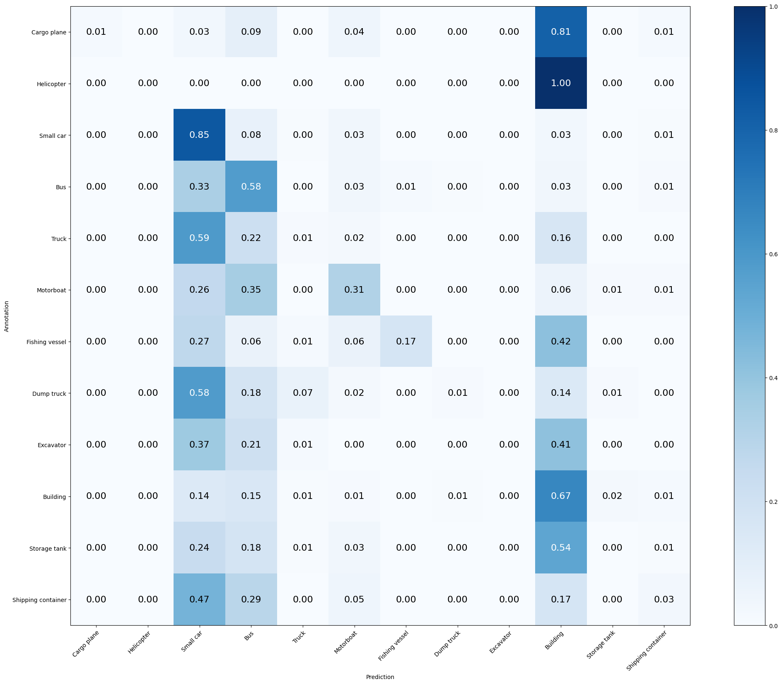

Mean Accuracy: 40.318%

Mean Recall: 21.936%

Mean Precision: 31.959%

> Cargo plane: Recall: 1.471% Precision: 100.000% Specificity: 100.000% Dice: 2.899%

> Helicopter: Recall: 0.000% Precision: 0.000% Specificity: 100.000% Dice: 0.000%

> Small car: Recall: 84.762% Precision: 39.337% Specificity: 68.044% Dice: 53.736%

> Bus: Recall: 57.534% Precision: 28.702% Specificity: 83.689% Dice: 38.298%

> Truck: Recall: 1.132% Precision: 15.789% Specificity: 99.146% Dice: 2.113%

> Motorboat: Recall: 31.461% Precision: 35.000% Specificity: 97.462% Dice: 33.136%

> Fishing vessel: Recall: 16.883% Precision: 72.222% Specificity: 99.757% Dice: 27.368%

> Dump truck: Recall: 0.855% Precision: 20.000% Specificity: 99.802% Dice: 1.639%

> Excavator: Recall: 0.000% Precision: 0.000% Specificity: 100.000% Dice: 0.000%

> Building: Recall: 66.532% Precision: 51.402% Specificity: 80.999% Dice: 57.996%

> Storage tank: Recall: 0.000% Precision: 0.000% Specificity: 99.496% Dice: 0.000%

> Shipping container: Recall: 2.597% Precision: 21.053% Specificity: 99.244% Dice: 4.624%  
3) only regularizer 60 epochs  
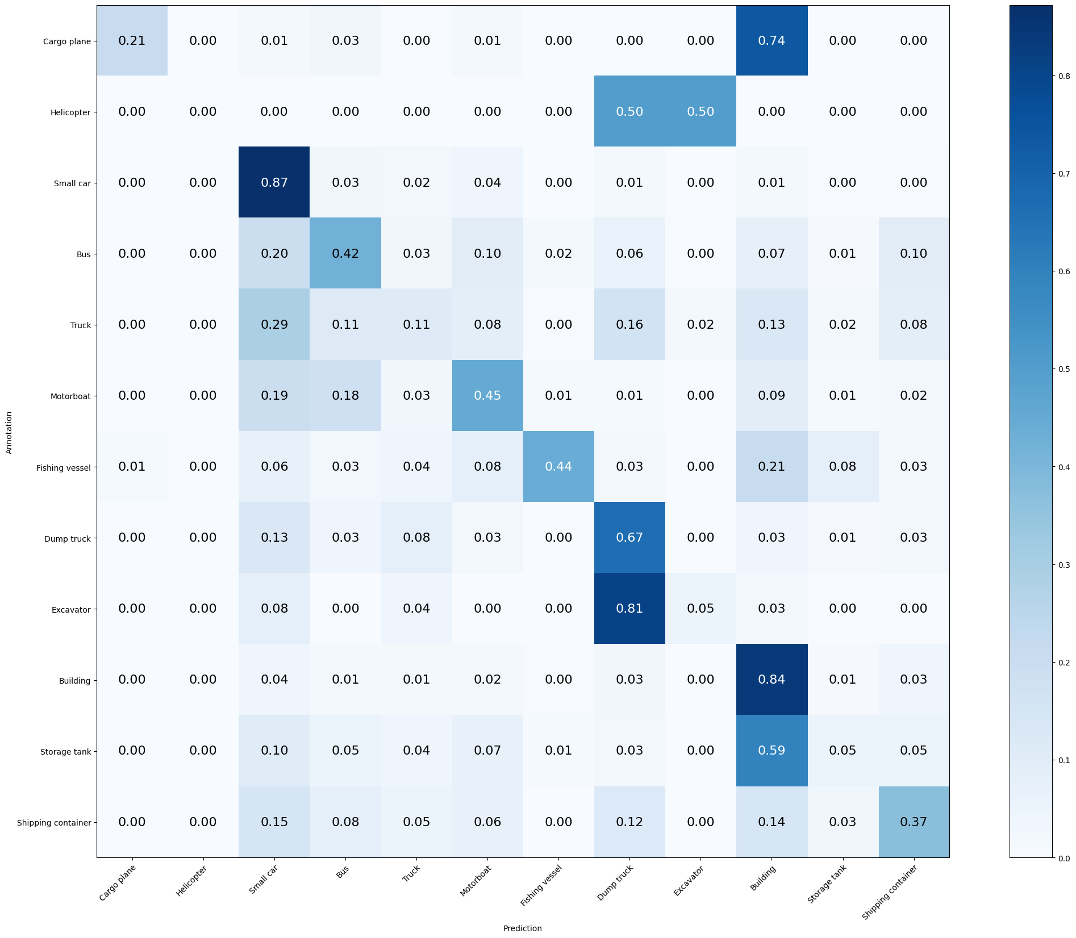

Mean Accuracy: 53.134%

Mean Recall: 37.259%

Mean Precision: 44.995%

> Cargo plane: Recall: 20.588% Precision: 93.333% Specificity: 99.952% Dice: 33.735%

> Helicopter: Recall: 0.000% Precision: 0.000% Specificity: 100.000% Dice: 0.000%

> Small car: Recall: 87.143% Precision: 62.245% Specificity: 87.078% Dice: 72.619%

> Bus: Recall: 42.009% Precision: 49.462% Specificity: 95.102% Dice: 45.432%

> Truck: Recall: 10.566% Precision: 33.735% Specificity: 97.064% Dice: 16.092%

> Motorboat: Recall: 44.944% Precision: 28.986% Specificity: 95.217% Dice: 35.242%

> Fishing vessel: Recall: 44.156% Precision: 77.273% Specificity: 99.515% Dice: 56.198%

> Dump truck: Recall: 66.667% Precision: 32.099% Specificity: 91.836% Dice: 43.333%

> Excavator: Recall: 5.128% Precision: 33.333% Specificity: 99.612% Dice: 8.889%

> Building: Recall: 83.669% Precision: 62.689% Specificity: 84.957% Dice: 71.675%

> Storage tank: Recall: 5.229% Precision: 24.242% Specificity: 98.741% Dice: 8.602%

> Shipping container: Recall: 37.013% Precision: 42.537% Specificity: 96.119% Dice: 39.583%  
  
4)only regularizer 100 epochs

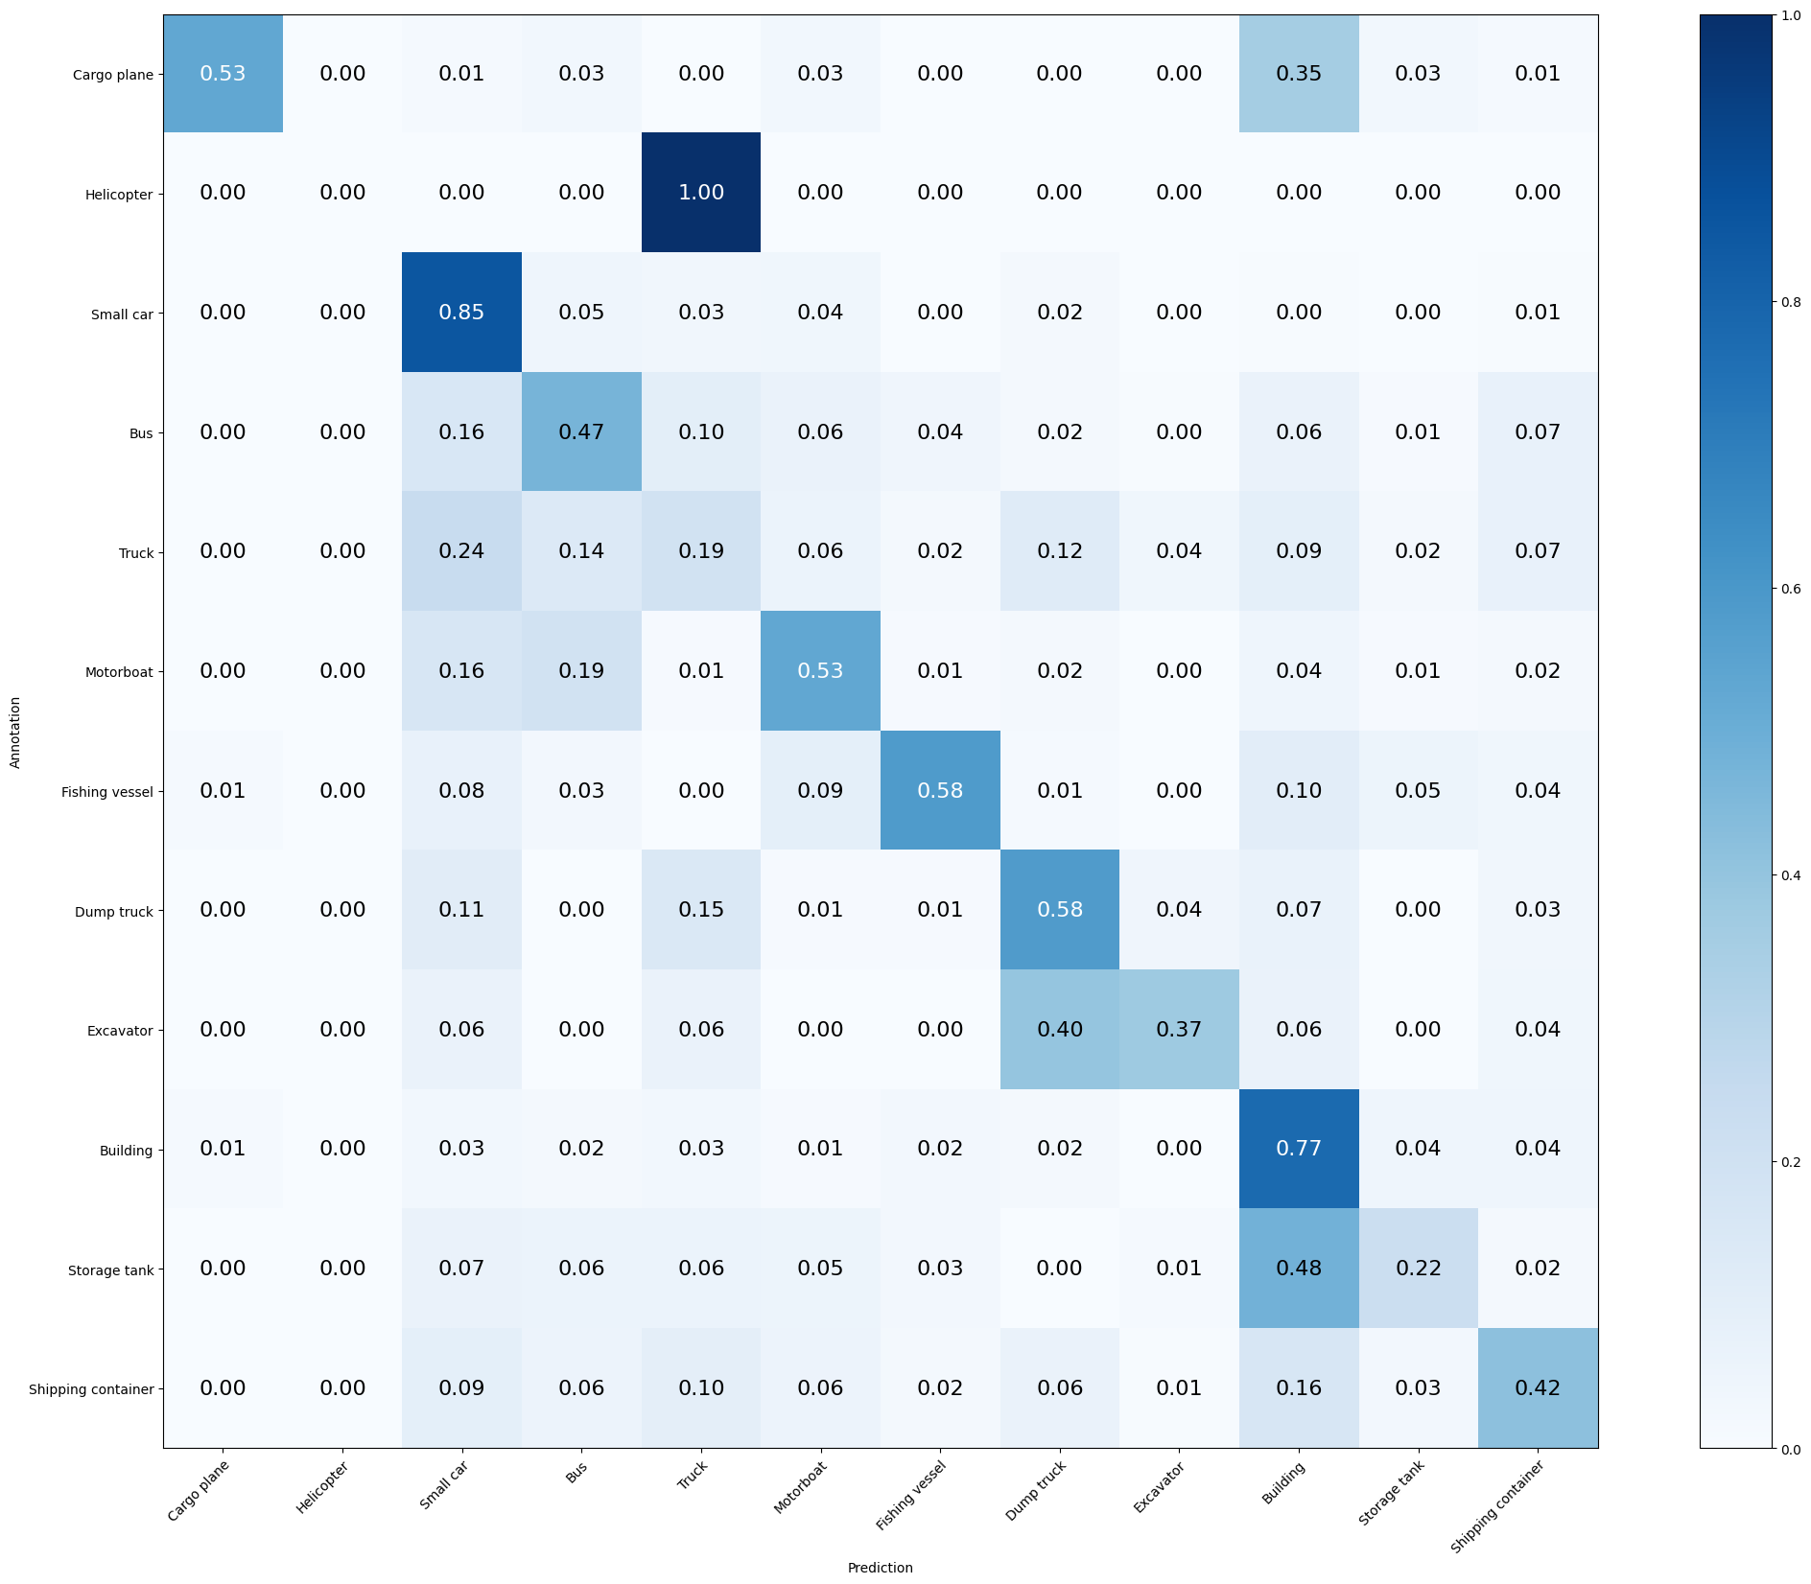

Mean Accuracy: 57.016%

Mean Recall: 46.017%

Mean Precision: 48.830%

> Cargo plane: Recall: 52.941% Precision: 81.818% Specificity: 99.614% Dice: 64.286%

> Helicopter: Recall: 0.000% Precision: 0.000% Specificity: 100.000% Dice: 0.000%

> Small car: Recall: 85.238% Precision: 67.167% Specificity: 89.814% Dice: 75.131%

> Bus: Recall: 47.032% Precision: 50.244% Specificity: 94.685% Dice: 48.585%

> Truck: Recall: 19.245% Precision: 34.000% Specificity: 94.714% Dice: 24.578%

> Motorboat: Recall: 52.809% Precision: 38.211% Specificity: 96.291% Dice: 44.340%

> Fishing vessel: Recall: 58.442% Precision: 55.556% Specificity: 98.253% Dice: 56.962%

> Dump truck: Recall: 58.120% Precision: 40.964% Specificity: 95.151% Dice: 48.057%

> Excavator: Recall: 37.179% Precision: 60.417% Specificity: 99.078% Dice: 46.032%

> Building: Recall: 77.419% Precision: 67.133% Specificity: 88.551% Dice: 71.910%

> Storage tank: Recall: 22.222% Precision: 44.737% Specificity: 97.884% Dice: 29.694%

> Shipping container: Recall: 41.558% Precision: 45.714% Specificity: 96.169% Dice: 43.537%

**MODEL 4**: Ridge Regularization (L2)

1)Alv only regularizer 100 epochs - stop at 54  
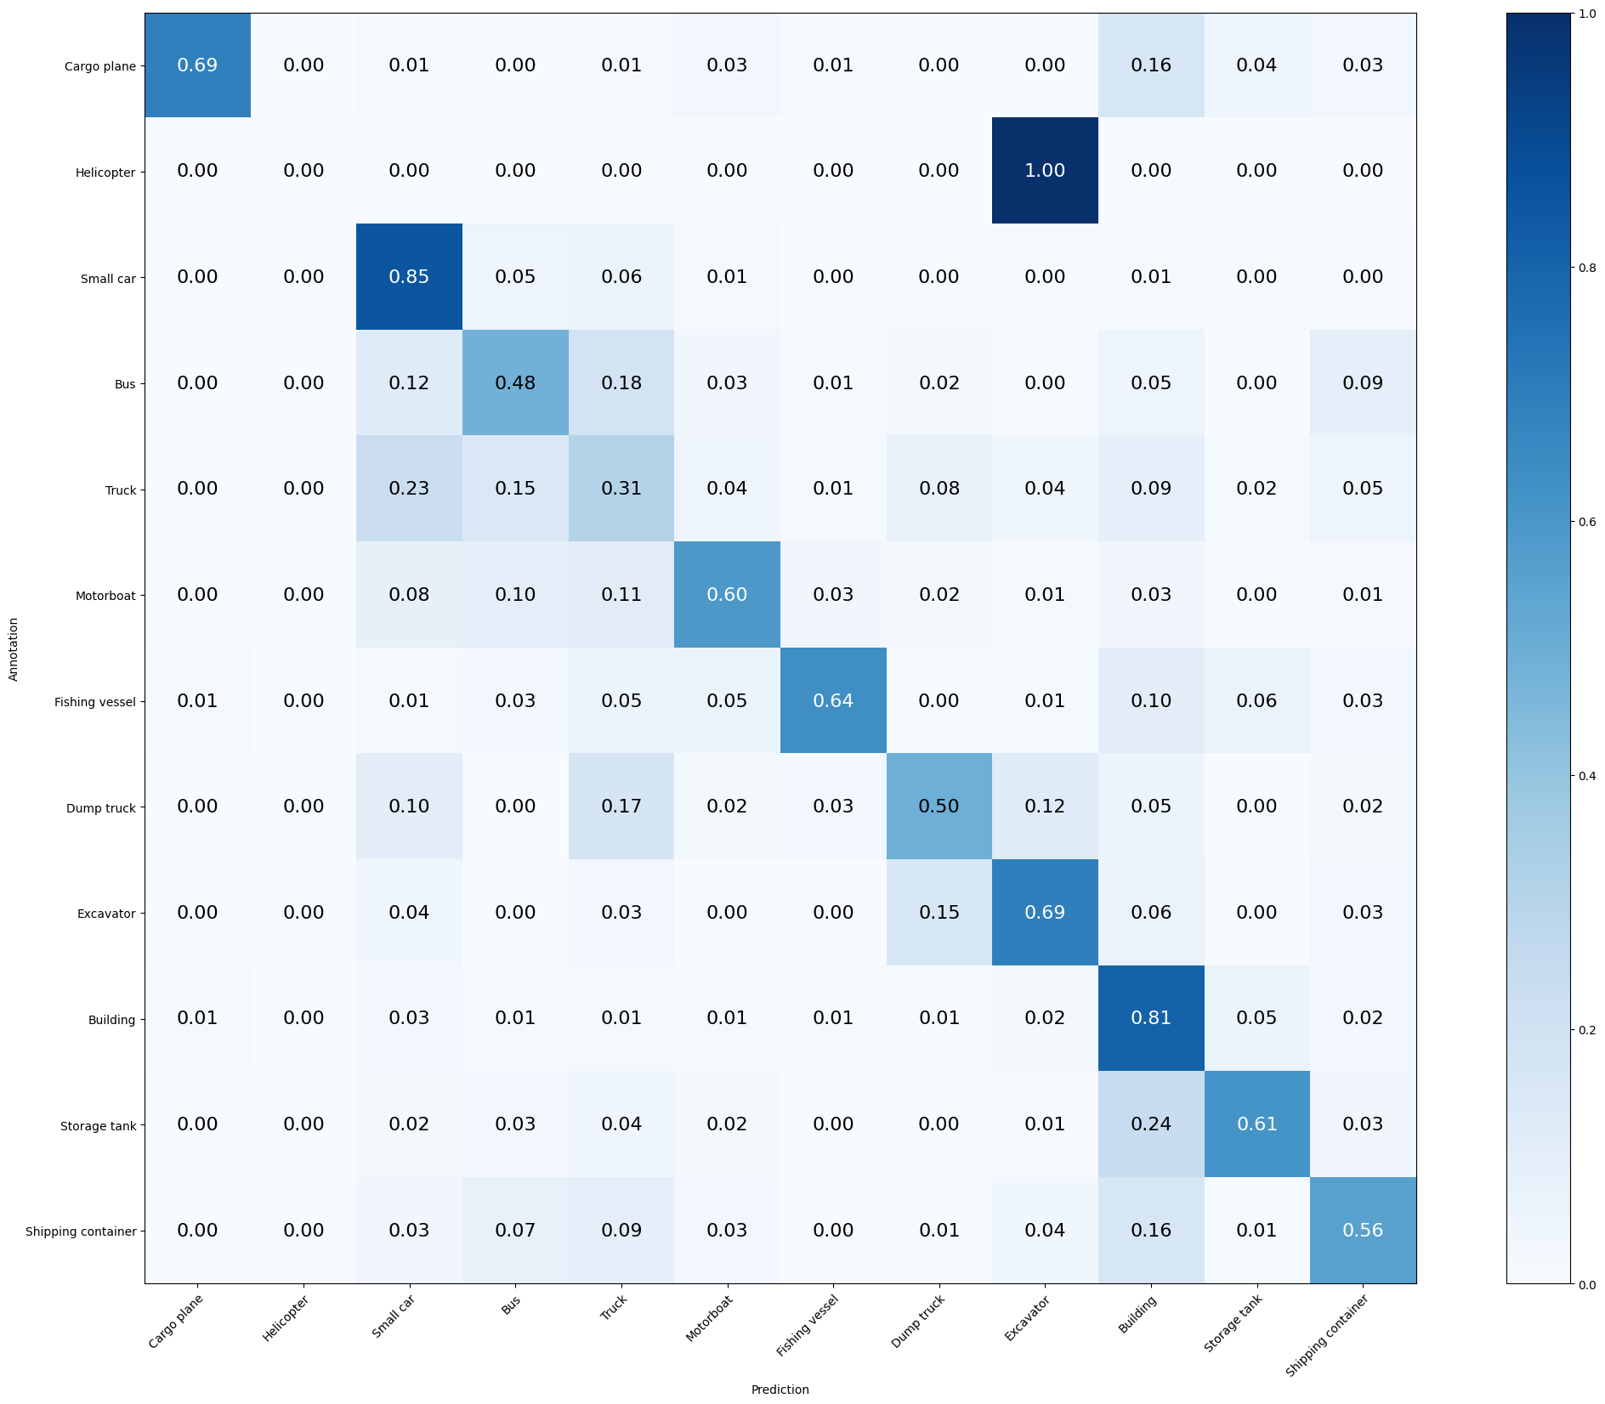  
  
Mean Accuracy: 64.920%

Mean Recall: 56.140%

Mean Precision: 57.665%

> Cargo plane: Recall: 69.118% Precision: 85.455% Specificity: 99.614% Dice: 76.423%

> Helicopter: Recall: 0.000% Precision: 0.000% Specificity: 100.000% Dice: 0.000%

> Small car: Recall: 85.476% Precision: 73.116% Specificity: 92.317% Dice: 78.814%

> Bus: Recall: 48.402% Precision: 53.535% Specificity: 95.206% Dice: 50.839%

> Truck: Recall: 30.566% Precision: 38.571% Specificity: 93.113% Dice: 34.105%

> Motorboat: Recall: 59.551% Precision: 55.789% Specificity: 97.950% Dice: 57.609%

> Fishing vessel: Recall: 63.636% Precision: 73.134% Specificity: 99.127% Dice: 68.056%

> Dump truck: Recall: 49.573% Precision: 56.863% Specificity: 97.823% Dice: 52.968%

> Excavator: Recall: 69.231% Precision: 52.941% Specificity: 97.670% Dice: 60.000%

> Building: Recall: 80.847% Precision: 74.953% Specificity: 91.839% Dice: 77.789%

> Storage tank: Recall: 61.438% Precision: 69.118% Specificity: 97.884% Dice: 65.052%

> Shipping container: Recall: 55.844% Precision: 58.503% Specificity: 96.925% Dice: 57.143%

2)**Model 3** (Hector) - L2 regulazation, Batch regulazation and LeakyReLU 0.01

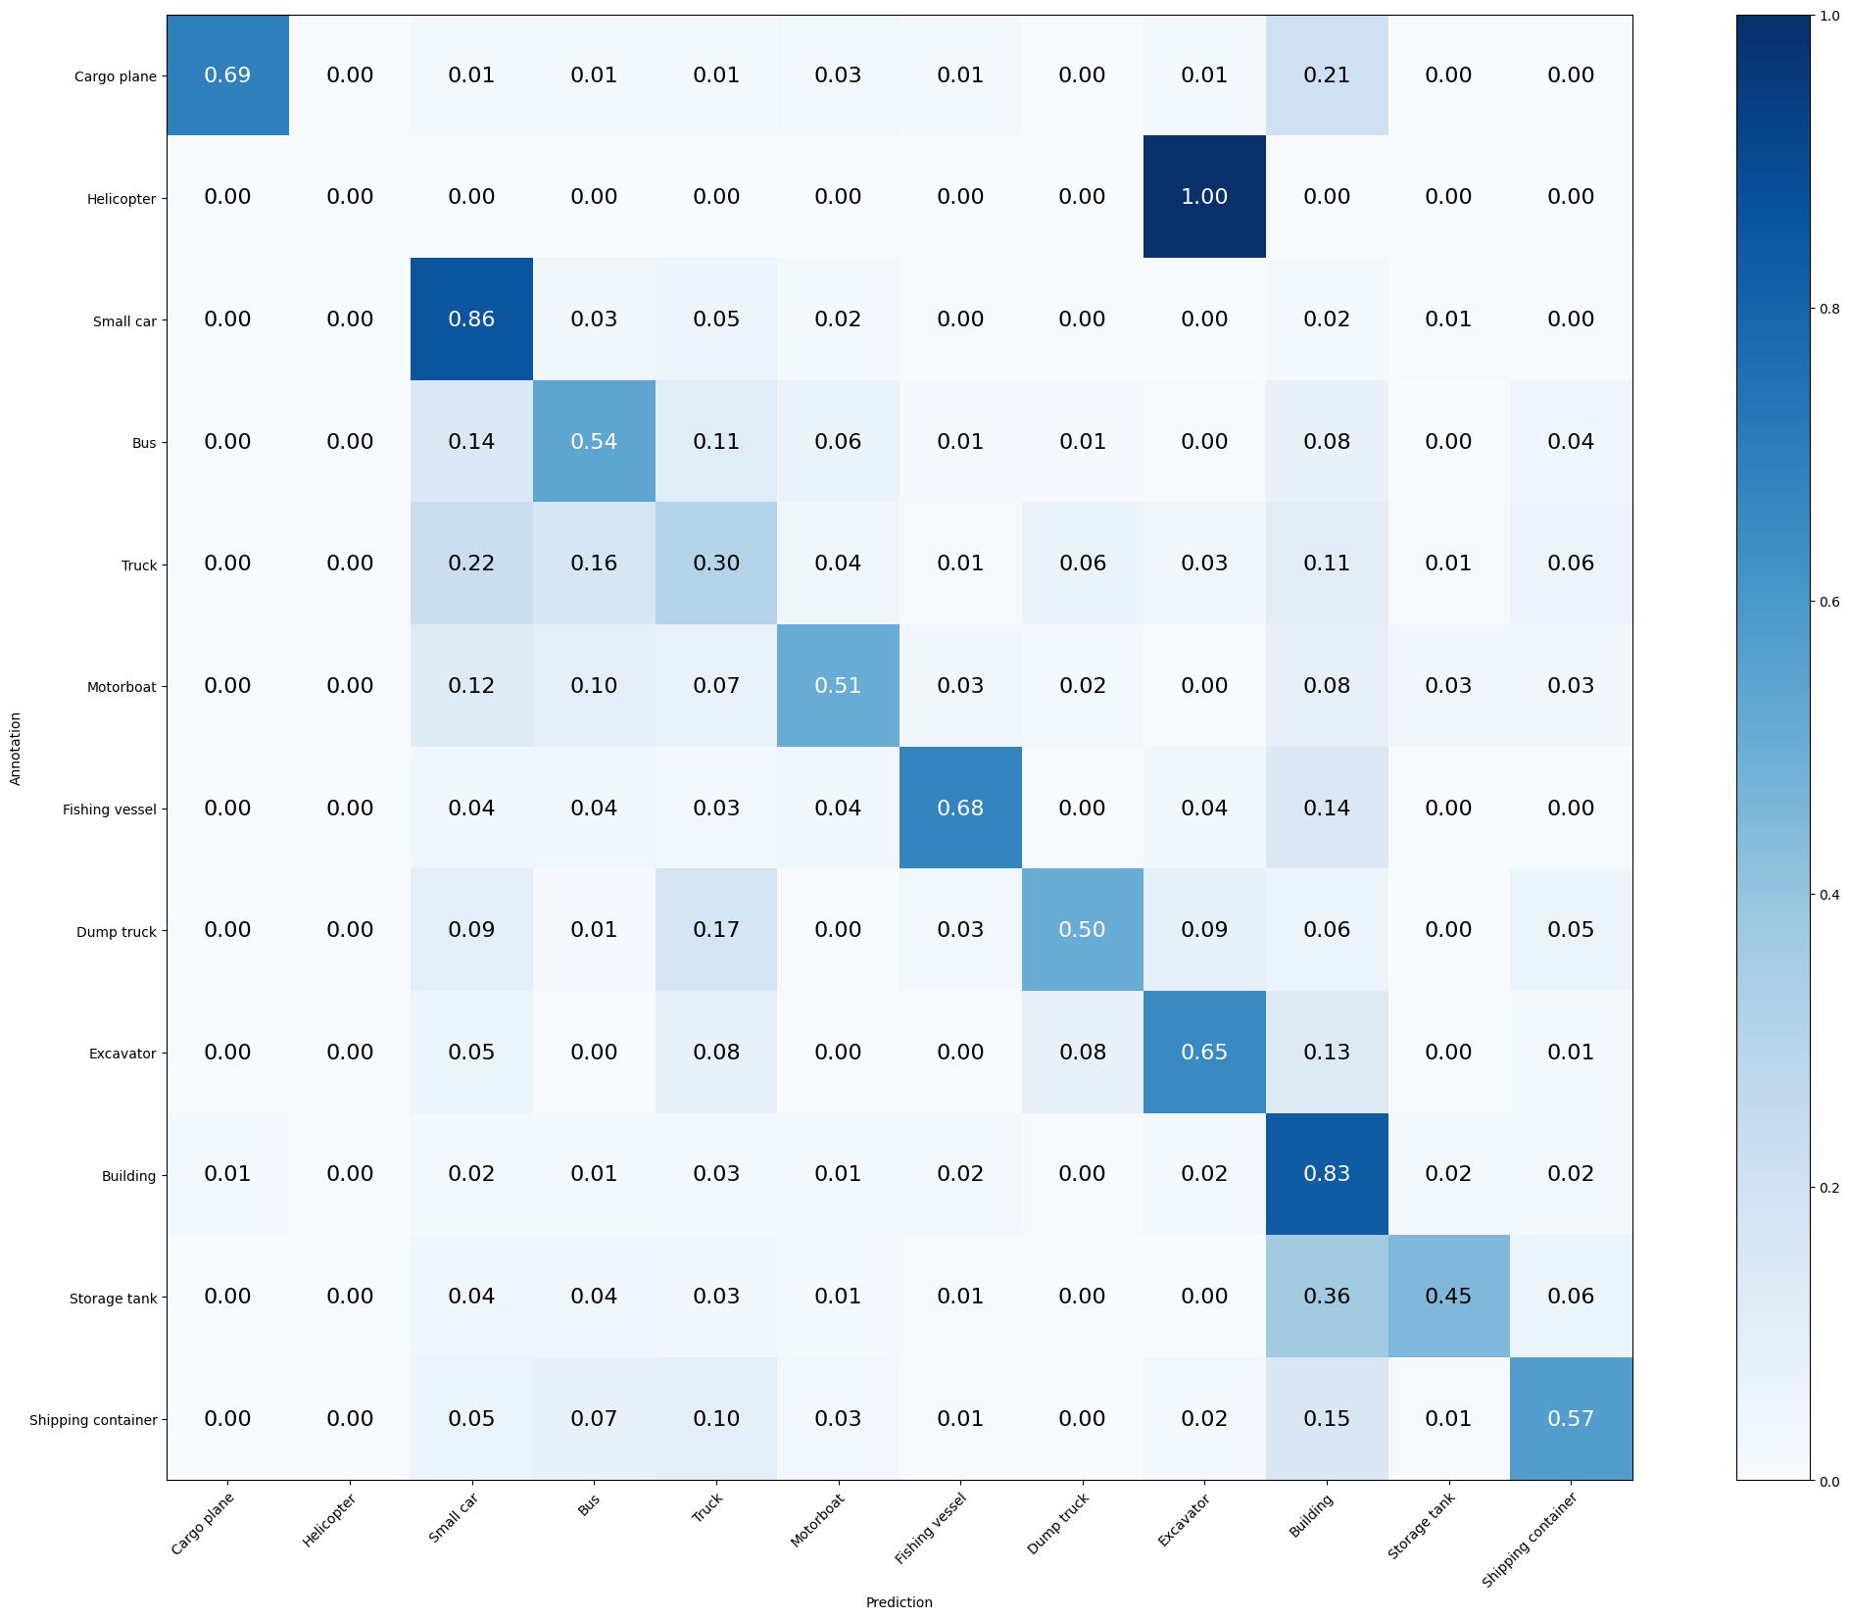

Mean Accuracy: 64.593%

Mean Recall: 54.843%

Mean Precision: 58.791%

> Cargo plane: Recall: 69.118% Precision: 88.679% Specificity: 99.710% Dice: 77.686%

> Helicopter: Recall: 0.000% Precision: 0.000% Specificity: 99.953% Dice: 0.000%

> Small car: Recall: 85.714% Precision: 71.571% Specificity: 91.676% Dice: 78.007%

> Bus: Recall: 53.881% Precision: 55.660% Specificity: 95.102% Dice: 54.756%

> Truck: Recall: 30.189% Precision: 41.026% Specificity: 93.860% Dice: 34.783%

> Motorboat: Recall: 50.562% Precision: 48.387% Specificity: 97.657% Dice: 49.451%

> Fishing vessel: Recall: 67.532% Precision: 67.532% Specificity: 98.787% Dice: 67.532%

> Dump truck: Recall: 50.427% Precision: 65.556% Specificity: 98.466% Dice: 57.005%

> Excavator: Recall: 65.385% Precision: 57.303% Specificity: 98.155% Dice: 61.078%

> Building: Recall: 83.065% Precision: 69.360% Specificity: 88.916% Dice: 75.596%

> Storage tank: Recall: 45.098% Precision: 79.310% Specificity: 99.093% Dice: 57.500%

> Shipping container: Recall: 57.143% Precision: 61.111% Specificity: 97.177% Dice: 59.060%

**Model 5: L2 Regularization Before**, Batch regularization before and LeakyReLU 0.01

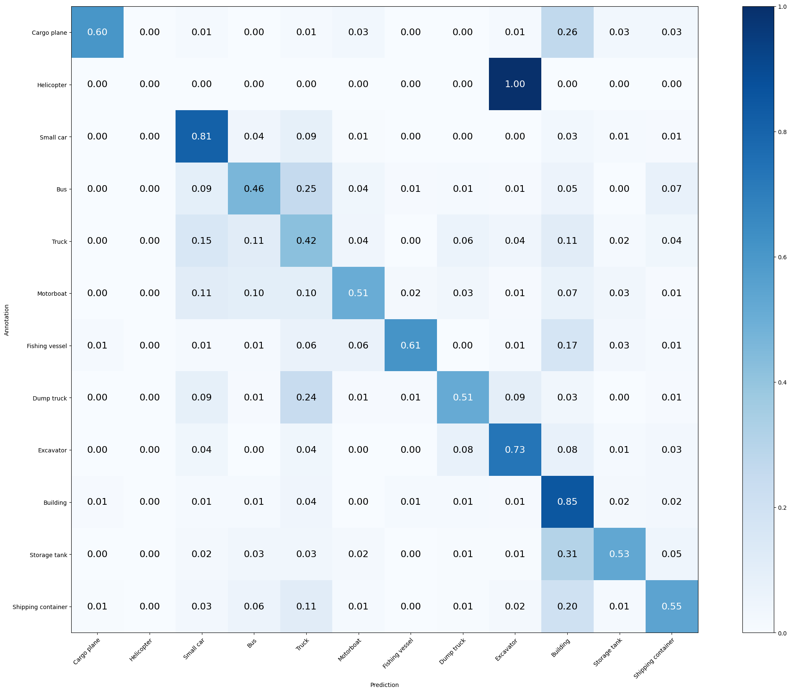

Mean Accuracy: 64.920%

Mean Recall: 54.798%

Mean Precision: 59.999%

> Cargo plane: Recall: 60.294% Precision: 87.234% Specificity: 99.710% Dice: 71.304%

> Helicopter: Recall: 0.000% Precision: 0.000% Specificity: 100.000% Dice: 0.000%

> Small car: Recall: 80.952% Precision: 77.449% Specificity: 94.237% Dice: 79.162%

> Bus: Recall: 46.119% Precision: 56.111% Specificity: 95.883% Dice: 50.627%

> Truck: Recall: 41.887% Precision: 38.276% Specificity: 90.443% Dice: 40.000%

> Motorboat: Recall: 50.562% Precision: 55.556% Specificity: 98.243% Dice: 52.941%

> Fishing vessel: Recall: 61.039% Precision: 79.661% Specificity: 99.418% Dice: 69.118%

> Dump truck: Recall: 51.282% Precision: 61.224% Specificity: 98.120% Dice: 55.814%

> Excavator: Recall: 73.077% Precision: 60.000% Specificity: 98.155% Dice: 65.896%

> Building: Recall: 84.879% Precision: 70.167% Specificity: 89.099% Dice: 76.825%

> Storage tank: Recall: 52.941% Precision: 74.312% Specificity: 98.589% Dice: 61.832%

> Shipping container: Recall: 54.545% Precision: 60.000% Specificity: 97.177% Dice: 57.143%

**MODEL 5**: Dropout at 0.1

**MODEL 6**: Dropout at 0.5

**MODEL 7**: Dropout descendente 0.4 - 0.3 - 0.2 - 0.1

1. L2, 100 epoch, 0.6 - 0.4 - 0.3 - 0.1 -best epoch 69(aprox)

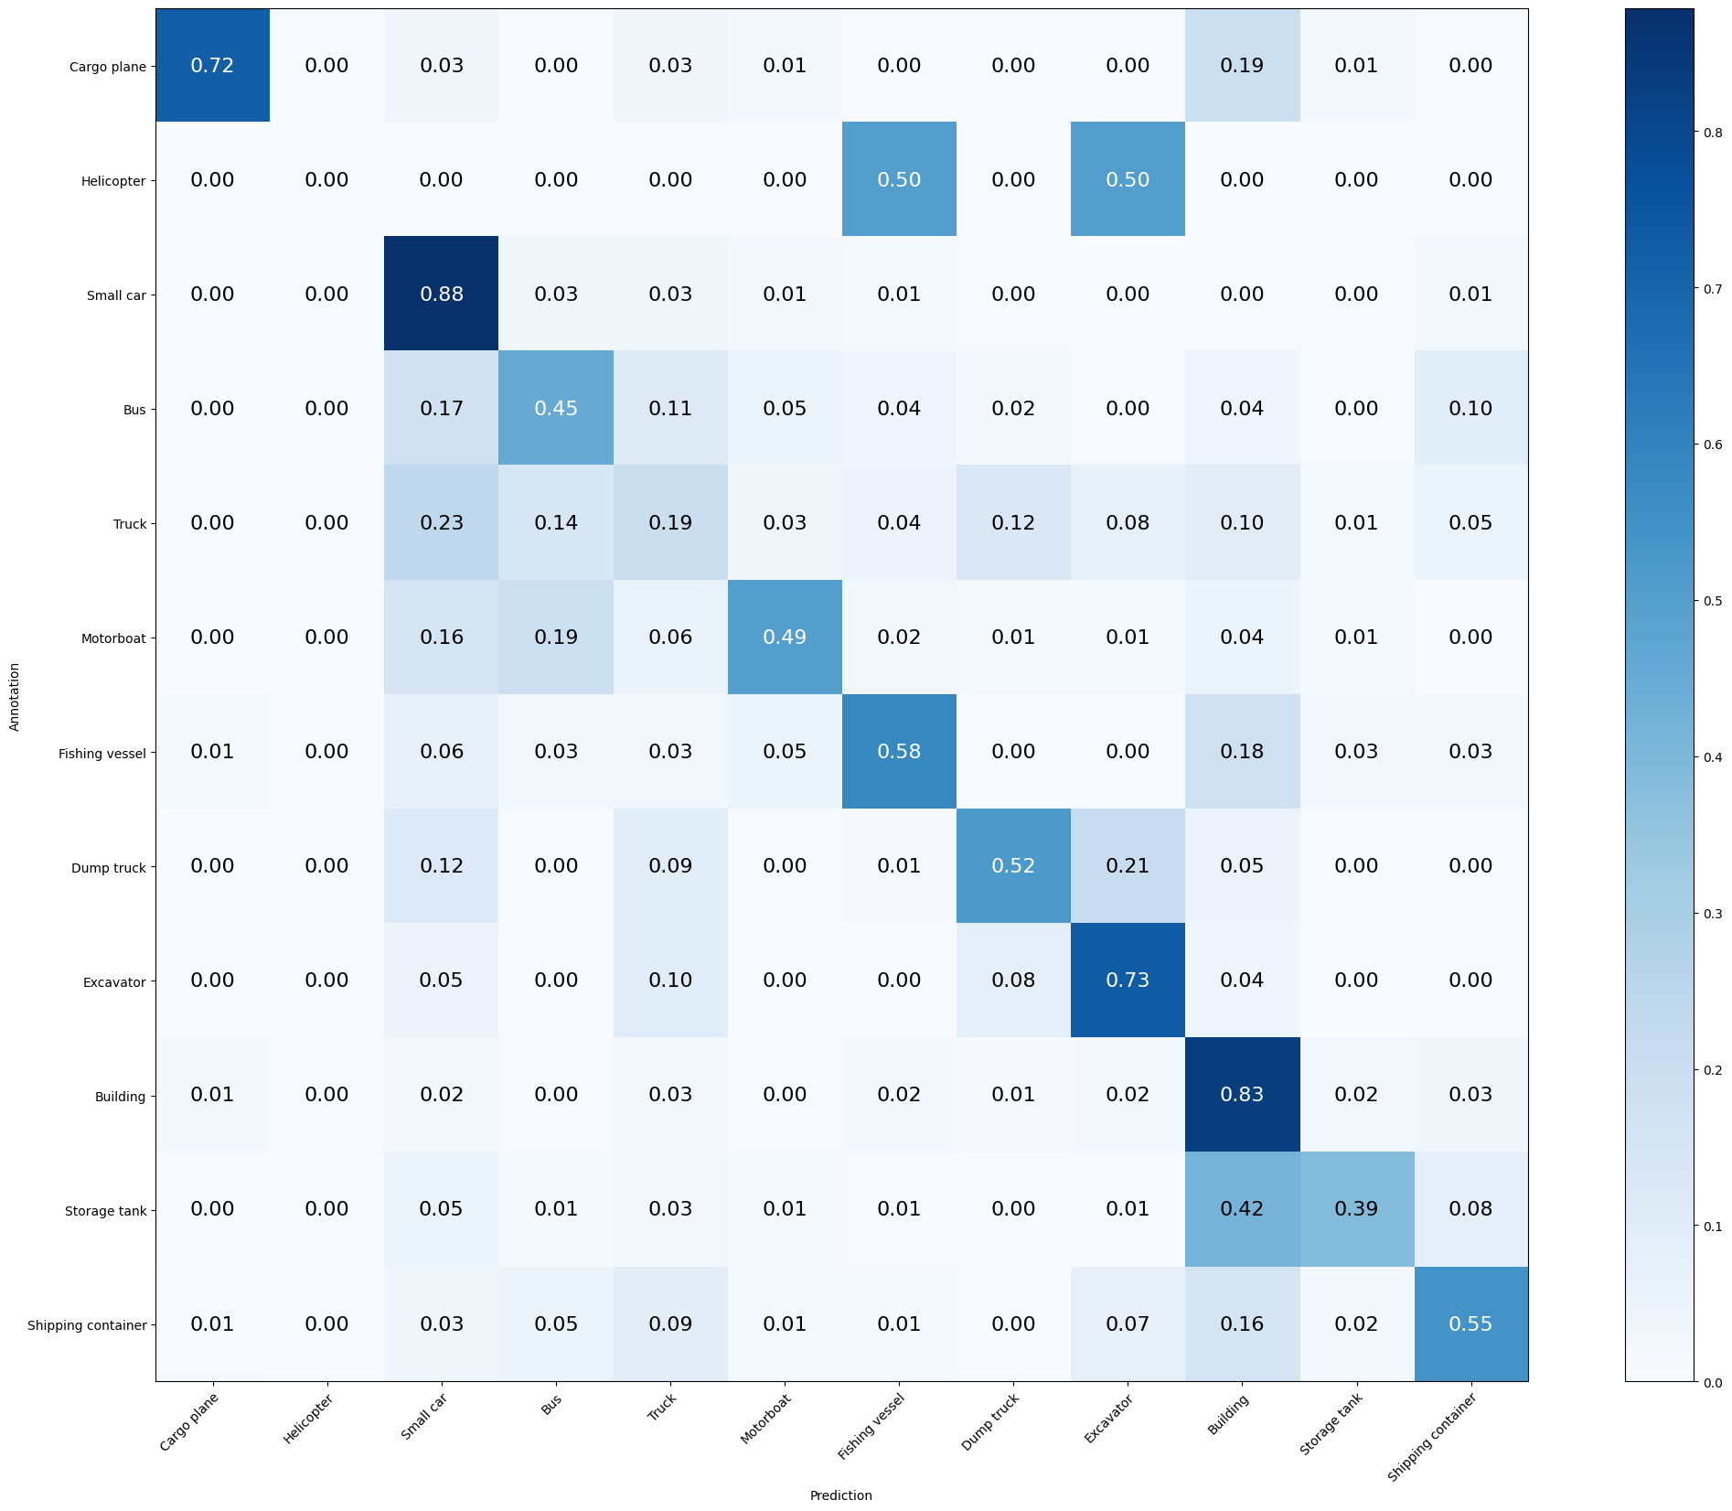

Mean Accuracy: 62.254%

Mean Recall: 52.819%

Mean Precision: 53.801%

> Cargo plane: Recall: 72.059% Precision: 84.483% Specificity: 99.565% Dice: 77.778%

> Helicopter: Recall: 0.000% Precision: 0.000% Specificity: 100.000% Dice: 0.000%

> Small car: Recall: 87.857% Precision: 69.492% Specificity: 90.570% Dice: 77.603%

> Bus: Recall: 45.205% Precision: 55.000% Specificity: 95.779% Dice: 49.624%

> Truck: Recall: 19.245% Precision: 34.228% Specificity: 94.768% Dice: 24.638%

> Motorboat: Recall: 49.438% Precision: 53.659% Specificity: 98.145% Dice: 51.462%

> Fishing vessel: Recall: 58.442% Precision: 51.724% Specificity: 97.962% Dice: 54.878%

> Dump truck: Recall: 52.137% Precision: 54.464% Specificity: 97.476% Dice: 53.275%

> Excavator: Recall: 73.077% Precision: 45.968% Specificity: 96.748% Dice: 56.436%

> Building: Recall: 83.266% Precision: 71.453% Specificity: 89.951% Dice: 76.909%

> Storage tank: Recall: 38.562% Precision: 70.238% Specificity: 98.741% Dice: 49.789%

> Shipping container: Recall: 54.545% Precision: 54.902% Specificity: 96.522% Dice: 54.723%

1. L2, 100 epoch, 0.5 - 0.4 - 0.25 - 0.15 -best 99  
   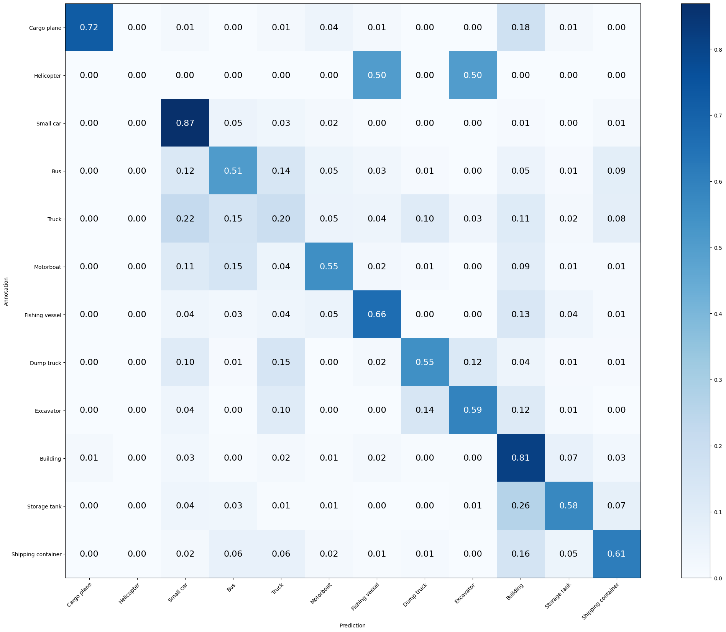

Mean Accuracy: 64.219%

Mean Recall: 55.354%

Mean Precision: 56.098%

> Cargo plane: Recall: 72.059% Precision: 87.500% Specificity: 99.662% Dice: 79.032%

> Helicopter: Recall: 0.000% Precision: 0.000% Specificity: 100.000% Dice: 0.000%

> Small car: Recall: 86.905% Precision: 72.854% Specificity: 92.084% Dice: 79.262%

> Bus: Recall: 50.685% Precision: 53.883% Specificity: 95.050% Dice: 52.235%

> Truck: Recall: 19.623% Precision: 34.899% Specificity: 94.821% Dice: 25.121%

> Motorboat: Recall: 55.056% Precision: 52.688% Specificity: 97.853% Dice: 53.846%

> Fishing vessel: Recall: 66.234% Precision: 59.302% Specificity: 98.302% Dice: 62.577%

> Dump truck: Recall: 54.701% Precision: 58.182% Specificity: 97.724% Dice: 56.388%

> Excavator: Recall: 58.974% Precision: 63.014% Specificity: 98.689% Dice: 60.927%

> Building: Recall: 81.452% Precision: 72.924% Specificity: 90.865% Dice: 76.952%

> Storage tank: Recall: 57.516% Precision: 61.972% Specificity: 97.280% Dice: 59.661%

> Shipping container: Recall: 61.039% Precision: 55.952% Specificity: 96.270% Dice: 58.385%

1. model4 L2, 100 epoch, 0.4 - 0.3 - 0.2 - 0.1 -best epoh 75

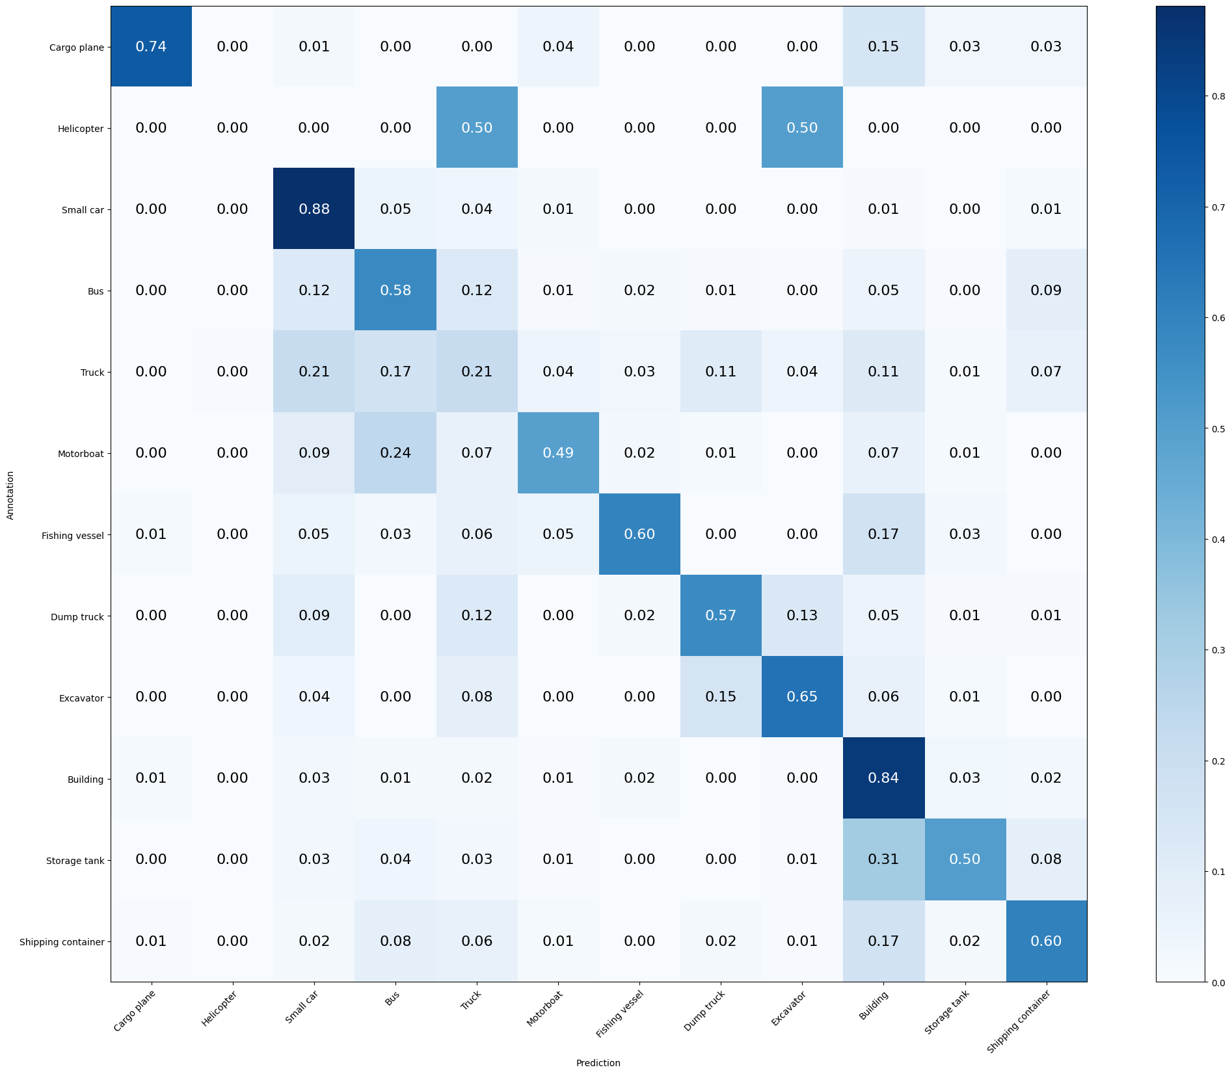

Mean Accuracy: 65.388%

Mean Recall: 55.578%

Mean Precision: 57.930%

> Cargo plane: Recall: 73.529% Precision: 86.207% Specificity: 99.614% Dice: 79.365%

> Helicopter: Recall: 0.000% Precision: 0.000% Specificity: 99.953% Dice: 0.000%

> Small car: Recall: 88.095% Precision: 74.148% Specificity: 92.491% Dice: 80.522%

> Bus: Recall: 57.534% Precision: 53.165% Specificity: 94.216% Dice: 55.263%

> Truck: Recall: 20.755% Precision: 35.948% Specificity: 94.768% Dice: 26.316%

> Motorboat: Recall: 49.438% Precision: 57.895% Specificity: 98.438% Dice: 53.333%

> Fishing vessel: Recall: 59.740% Precision: 65.714% Specificity: 98.836% Dice: 62.585%

> Dump truck: Recall: 57.265% Precision: 58.772% Specificity: 97.674% Dice: 58.009%

> Excavator: Recall: 65.385% Precision: 61.446% Specificity: 98.447% Dice: 63.354%

> Building: Recall: 84.476% Precision: 72.491% Specificity: 90.317% Dice: 78.026%

> Storage tank: Recall: 50.327% Precision: 71.963% Specificity: 98.489% Dice: 59.231%

> Shipping container: Recall: 60.390% Precision: 57.407% Specificity: 96.522% Dice: 58.861%